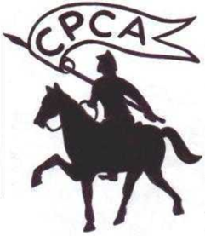
CPCA Youth Chess Championships 2011

The Central Province Chess Association cordially invites you to participate the above championship which will be held on 16th, 17th & 18th September at Lumbini Royal College, Kandy.
· Age Categories: Under 12, Under 14, (Participants should be under their relevant age category as at January 01st, 2011.) Boys & Girls sections separately.
· Rounds: 05 (Five), 1st round at 3.00 p.m. on 16th
· Equipments: Participants are expected to bring their own chess sets and chess clocks if available.
· Rules: General rules of FIDE will applicable.
· Prizes: Certificates and Medals will be awarded, Participation certificates will be awarded for all participants.
· Entry fee: Rs.400/- per player is payable. Entries should hand over to Mr.N Abeykoon, Mrs.Priyangika Ranasinghe,Miss Subagya Wijenayake ,Mr.Jagath Ketalawala,Mr Nuwan Liyanage or sent to Prabath Kehelella,"Pavana", Yalegoda,Handessa.
on or before 13th September 2011.(CPCA will not accept late entries for any reason)
Further Details Please contact: Nissanka Abeykoon 0712854440 / Prabath Kehelella. 0773887696 or
T. Wickremathunga- thameewick@ gmail.com
Entry Form
Name:
School:
Date of Birth:
Permanent Address:
Telephone No:
Date:…………………………………… Signature:………………

