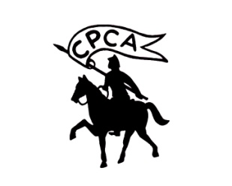
Central Province Junior Chess Championships 2011

The Central Province Chess Association cordially invites you to participate the above championship which will be held on 05th & 06th November at The National Institute of Co-operative Development, Polgolla, Kandy.
· Age Categories: Under 07, Under 09 & Under 11 (Participants should be under their relevant age category as at January 01st, 2011.) Boys & Girls sections separately.
· Rounds: 06 (Six), 1st round at 8.00 a.m. on 05th November
· Equipments: Participants are expected to bring their own chess sets and chess clocks if available.
· Rules: General rules of FIDE will applicable.
· Prizes: Certificates and Medals will be awarded; all participants will be awarded Participation certificates.
· Entry fee: Rs.400/- per player. Entries should be sent to cpcasrilanka@gmail.com or could be hand over to Kingo International School, Heerassagala road, Mulgampola only on Sundays, by 6pm.

On or before 02nd November 2011 (CPCA will only accept 350 entries & will not accept late entries for any reason)
Please contact the following personal before you submit your entries:
Prabath Kehelella. 077-3887696,
T Wickremathunga 072-6028939 or M Dilshan 077-2311523,

Entry Form
Name:
School:
Age Group:
Gender:
Date of Birth:
Permanent Address:
Telephone No:
Date: …………………………………… Signature: ………………

