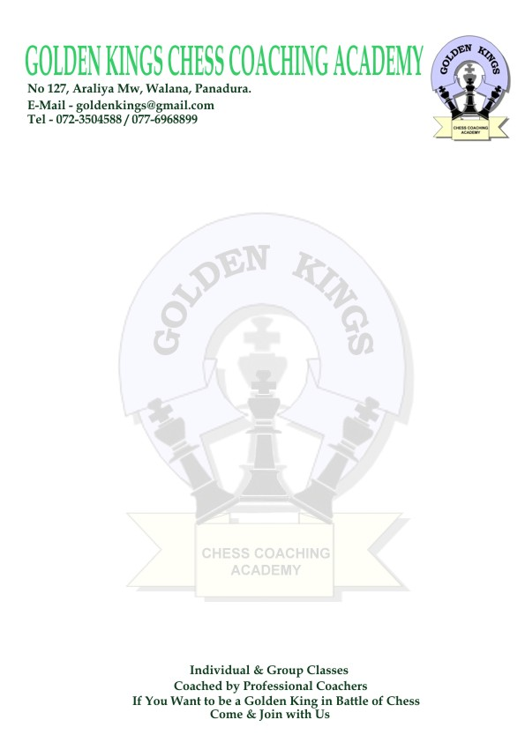
GOLDEN KINGS CHESS COACHING ACADEMY
GOLDEN KINGS CHESS COACHING ACADEMY
No 306 A, Dibbedda, Panadura.
E-Mail - goldenkingschess@gmail.com
Tel - 011-4572322 / 072-3504588

Golden Kings Chess Coaching Academy
Western Province Team Chess Championship – 2011

The GOLDEN KINGS CHESS COACHING ACADEMY made arrangement to conduct a
Western Province Team Chess Championship.

At Presbyterian Girls School – Dehiwala on 26th and 27th of February 2011, to find out the best Team Warriors in 64 square game in Western Province.

Event :
There will be total of 9 separate Team events (Under 8, 10, 12, 14 Boys / Girls and a Open Event)
The event will be held according to the Swiss System (minimum 5 rounds)

Dates and Venue :
Presbyterian Girls School – Dehiwala on 26th and 27th of February 2011
Opening ceremony will take place on the above date at 8.00 a.m.

Eligibility :
Those who are below the respective age group before 1st of January 2011

The Team :
4 Players per Team

Entry Fee :
An entry fee of Rs 350/= will be charged ( Per Player )

Registrations :
On 26th of February 2011 at Presbyterian Girls School – Dehiwala (6.30 a.m – 7.30 a.m )

Prizes :
Boys & Girls separately in under 8/10/12/14 Events
Champions-Gold medals & Certificates
1st runners up-Silver medals & Certificates
2nd runners up-Bronze medals & Certificates
Board Prizes -Medals & Certificates

Every player will be given a certificate of participation

GOLDEN KINGS CHESS COACHING ACADEMY
GOLDEN KINGS CHESS COACHING ACADEMY
No 306 A, Dibbedda, Panadura.
E-Mail - goldenkingschess@gmail.com
Tel - 011-4572322 / 072-3504588

Program

26th of February 2011

8.00 a.m – 8.15 a.m-Opening ceremony
8.30 a.m – 5.30 p.m-1st , 2nd and 3rd Rounds

27th of February 2011

7.30 a.m – 1.30 p.m-4th , and 5th Rounds
1.30 p.m – 4.30 p.m-6th Round ( if needed )
4.30 p.m – 5.30 p.m-Awards ceremony

All Inquiries & Entries to:

Golden Kings Chess Coaching Academy
Tel- 011-4572322
E-mail- goldenkingschess@gmail.com

Mr. C.S.Kumarawadu (Director – Training )
Tel- 072-9559333 / 072-3504588
E-mail- kumarawadu@gmail.com

Mrs. K.B. Nelum Samarasekara (Director - Tournament Organizing)
Tel- 072-8036986
E-mail- kbnsamarasekara@gmail.com

Come Play and Show that you are the Best of 64 Square Game

--------------------------------------------------
K.B. Nelum Samarasekara
Director - Tournament Organizing

