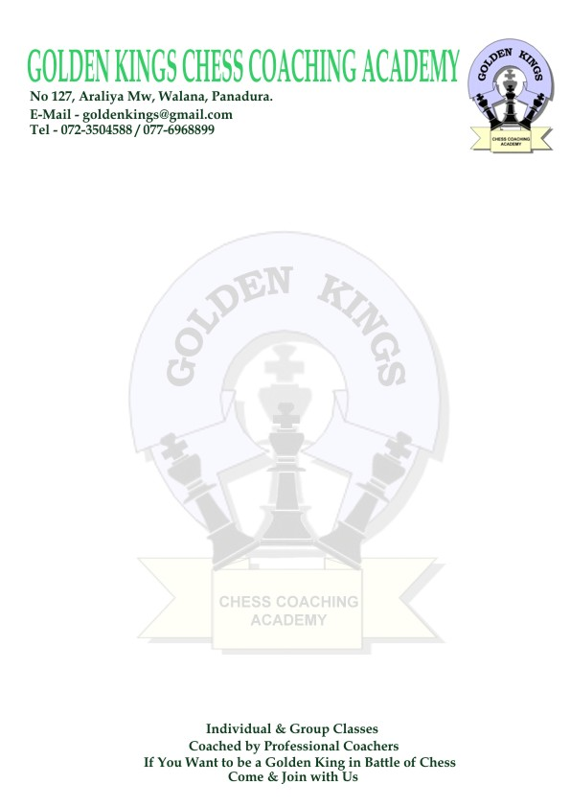
Golden Kings Chess Coaching Academy
3rd Annual
Western Province Age Group Individual Chess Championship – 2010

The GOLDEN KINGS CHESS COACHING ACADEMY made arrangement to conduct the
3rd Annual Western Province Age Group Individual Chess Championship 2010

At Buddhist Girls School – Mt. Lavinia on 2nd and 3rd of October 2010, to find out who are the best in 64 square game in Western Province.

Event :
There will be total of 10 separate individual events (Under 8, 10, 12, 14 and 16 years, Boys and Girls )
The event will be held according to the Swiss System (minimum 5 rounds)

Dates and Venue :
Buddhist Girls School – Mt. Lavinia on 2nd and 3rd of October 2010
Opening ceremony will take place on the above date at 7.30 a.m.

Eligibility :
Those who are below the respective age group before 1st of January 2010

Entry Fee :
An entry fee of Rs 300/= will be charged

Registrations :
On 16th and 23rd of September 2010 at Buddhist Girls School – Mt. Lavinia (3.00p.m-5.00p.m)
On 17th and 24th of September 2010 at Princess of Wales College – Moratuwa (3.00p.m-5.00p.m)

Prizes :
Boys & Girls separately
Champions-Gold medal & a Certificate
1st runners up-Silver medal & a Certificate
2nd runners up-Bronze medal & a Certificate
4th – 10th -Merit Certificate

Every player will be given a certificate of participation

****ALL THE ENTRIES MUST HANDED OVER TO THE ORGANIZING COMMITTEE OF THE TOURNAMENT ON OR BEFORE 24TH OF SEPTEMBER 2010****

Program

02nd of October 2010

7.30 a.m – 8.00 a.m-Opening ceremony
8.15 a.m – 5.30 p.m-1st , 2nd and 3rd Rounds (with the lunch break)

***All the certificates for participation will be given on this day***

03rd of October 2010

7.30 a.m – 1.30 p.m-4th , and 5th Rounds
1.30 p.m – 4.30 p.m-6th Round ( if needed )
4.30 p.m – 5.30 p.m-Awards ceremony

All Inquiries & Entries to:

Golden Kings Chess Coaching Academy
Tel- 011-4572322
E-mail- goldenkingschess@gmail.com

Mr. C.S.Kumarawadu (Director – Training )
Tel- 072-3504588
E-mail- kumarawadu@gmail.com

Mrs. K.Nelum Samarasekara (Director - Tournament Organizing)
Tel- 072-8036986
E-mail- kbnsamarasekara@gmail.com

Come Play and Show that you are the Best of 64 Square Game

