5th Colombo International Chess Festival '11
International Rating Chess Tournament



From 16th to 22nd February 2012
Colombo, Sri Lanka.

5th Colombo International
Chess Festival 2012

Entry Form

Name …………..................................

Birthday…………..............................

Address & Telephone…..…………

……………………………………….

E-mail:………………………………

ELO Rating…..……… FIDE ID………

Club/ School…..……………............

CFSL ID……………………………

I hereby agree to abide by the Rules and Regulations of the event. All the details given above are true to the best of my knowledge.

Signature Date

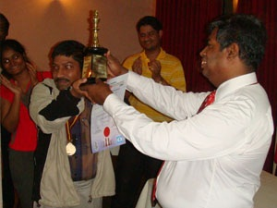
2008 Champion, IM PDS Girinath

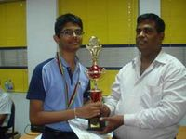
2009 Champion, IM Srinath (India)

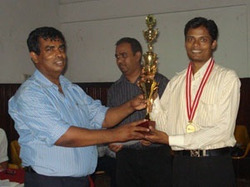
2010 Champion, Romesh Weerawardena (Sri Lanka)

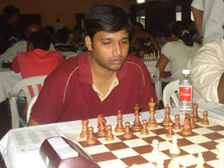
2011 Champion, Navin Kanna (India)

5th Colombo International Chess Festival

On be half of the Chess Federation of Sri Lanka, the Passed Pawn Chess Club is organizing the 5th Colombo International Chess Festival 2012, an International Rating Open Chess event for the 5th successive year with a total prize fund of nearly Rs. 250,000/= in cash and other attractive awards. The event will be played according to the Swiss System in 9 rounds from 15th to 22nd February 2012.

Venue : Colombo.

Schedule: 16th February - Arrival
17th to 20th February - Round 1 to 8
21st February - Round 9 and PDF
22nd February - Departure

Eligibility : Open for all

Prizes :
Champion - Trophy, Gold Medal & Rs. 50,000/=
1st Runner up - Silver Medal & Rs. 30,000/=
2nd Runner up - Bronze Medal & Rs. 20,000/=
4th & 5th - Rs. 10,000/= each
6th to 10th - Rs. 5,000/= each

Best Girls
Champion - Trophy, Gold Medal & Rs. 10,000/=
1st Runner up - Silver Medal, Rs. 6000/=
2nd Runner up - Bronze Medal Rs. 4000/=

Best Unrated Player
Champion - Gold Medal & Rs. 5,000/=
1st Runner up - Silver Medal & A Chess Set
2nd Runner up - Bronze Medal & A Chess Set

Best Under 8, 10, Under 12, Under 15, Boys & Girls separately (6 sets of awards)
Champion - Gold Medal & Rs. 5,000/=
1st Runner up - Silver Medal & A Chess Set
2nd Runner up - Bronze Medal & A Chess Set

Best Player - Rating category 1800 to 2000
Champion - Gold Medal & Rs. 5,000/=
1st Runner up - Silver Medal & A Chess Set
2nd Runner up - Bronze Medal & A Chess Set

Best Player - Rating category 1600 to 1800 Champion - Gold Medal & Rs. 5,000/=
1st Runner up - Silver Medal & A Chess Set
2nd Runner up - Bronze Medal & A Chess Set

Best Player - Rating category less than 1600 Champion - Gold Medal & Rs. 5,000/=
1st Runner up - Silver Medal & A Chess Set
2nd Runner up - Bronze Medal & A Chess Set

All participants will be provided with certificates and a souvenir.

Accommodation : All foreign players with the ELO rating of 2200 or more will be provided accommodation only. All foreign title players (above FM) will be provided accommodation with three meals. All other foreign players are charged with 50 US $ for accommodation only.

Travel Grant
GMs, IMs, WGMs, WIMs with more than 2300 rating will be given a travel grant of Rs. 12,000/=

Entry Fee
All title players and players having a rating of above 2200 are free.

Rating category 1800 - 2200 : Rs. 1000/=
Rating category less than 1800 : Rs. 2,000/=
Unrated players : Rs. 4,000/=
A discount of Rs. 500/= is granted for the players registering before 15th February 2012 with the relevant entry fee. (including rated players)
Normal Entry fee will be charged from after 15th February 2012.
Late fee of Rs. 500/= will be charged for the entries received on 17th of February 2012

All Inquiries & entries to :
Mr. Luxman Wijesuriya
Chairman, Organizing Committee,
151/12,Siridamma Mawatha, Colombo 10, Sri Lanka.
Telephone : 0715397829
Fax : 0112650622
Email - godigamu@yahoo.com

Be a part of this memorable Chess event!

Luxman Wijesuriya
Chairman, Organizing Committee
Note:
1. All amounts are in Sri Lankan Rupees.
2. All Sri Lankan Chess Players should have the Chess Federation Registration to play in this event. The CFSL ID is compulsory.

Also can be registered with:
1. Mr. RS Kalugampitiya (Kandy) 0715601237
2. Mr. Werochana Perera (Kurunegala)0717400249
3. Mr. Gihan Dinesh (Galle)0714498167
4. Mr. Jagath Ketalawala (Kegalle)0715130654
5. Mr. Shamin De Moraes (Gampaha) 0712297180
6. Mr. Rajiv Thilakaratne (Polonnaruwa)0776221847
7. Mr. Malith Akalanka (Ambalangoda)0718740372

