Anuruddha Wins Colombo International Chess Festival
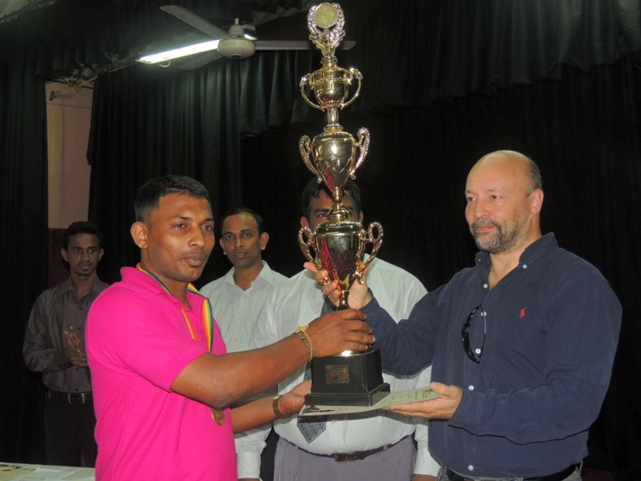
Anuruddha receiving his awards from CEO, Mr. Geffery Borg.
G.C. Anuruddha former National Chess Champion won the Championships yesterday, at the 6th Colombo International Chess Festival held at the Public Library Auditorium. Anuruddha scored total of 8 points out of nine with Young Chathupa Karunaratne and FIDE Master TSS Pieris , but was having the better tie breaker to win the title.
The 6th Colombo International was held from 17th to 21st of August 2013 at the Public Library in Colombo, Sri Lanka. There was a record number of participation which over 400 players. This was 9 round Swiss System event with normal Fisher mode time control.
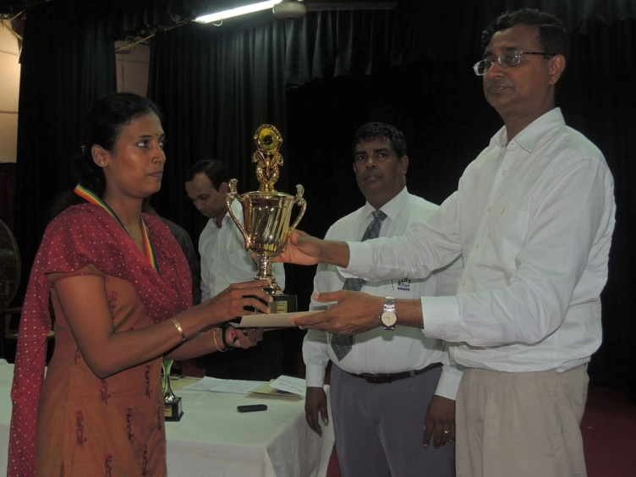
CFSL President awards Women’s Champion
Anuruddha won the trophy, Gold Medal and Rs. 33,333/= since the 1st place was shared among 3 of them. Chathupa Karunaratne a 15 year boy from southern Sri Lanka was excellent to share the 1st place in this grand event and he had to satisfy with the Silver Medal and same amount of money. FM TSS Pieris also showed his strength by scoring the same points to win the Bronze Medal on the weak tie breaker.
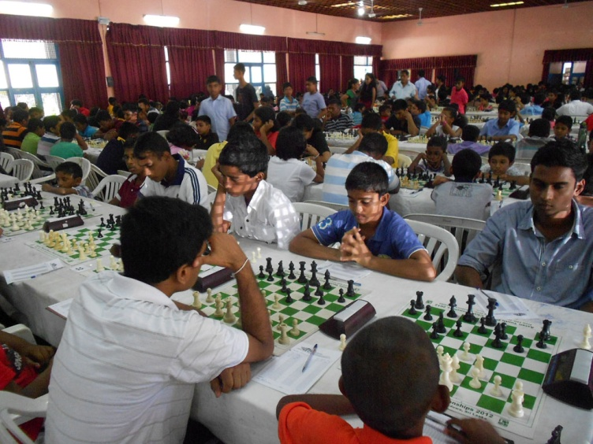
Huge playing hall
Rasheen De Silva, SA Chandrasiri and Dineth Naotunna tied for the equal 4th place while Isuru Alahakoon, Vasanta Wettasinghe, S Lamahewa, Laksith Randil and shakthi Ediriweera shared the equal 7th place.
S. Vithiyarani who is from the war affected Jaffna district displayed a great strength by winning the Women’s Championships with 6 ½ points. This performance might be a great strength in popularizing the Game in the Northern Province. She won the Trophy, Gold Medal for best women and the cash award. Shelani De Silva and WIM Nelunika Methmani also scored 6 ½ points but has to satisfy with the Silver and Bronze in Women’s according to the tie breaker.
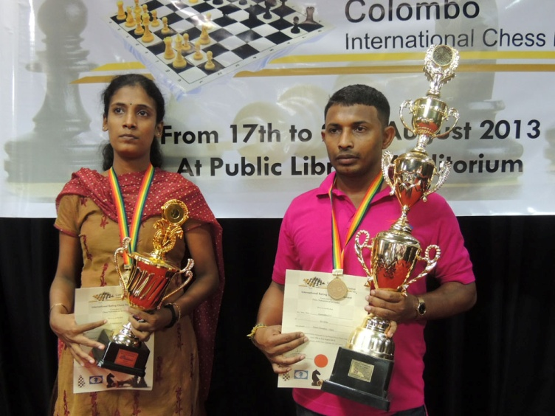
We are the Champions
Mr. Geoffery Borg of FIDE grace the awarding ceremony as the Chief guest while Mr. Upali Gunasekara, the President of Chess federation of Sri Lanka was guest of honour. Prof. Chandana Gunathilake who is the 1st Rated player in Sri Lanka and Mrs Suneetha Wijesuriya the only Gold medalist in Olympiad was also present with the other officials of CFSL at the Awards Ceremony.
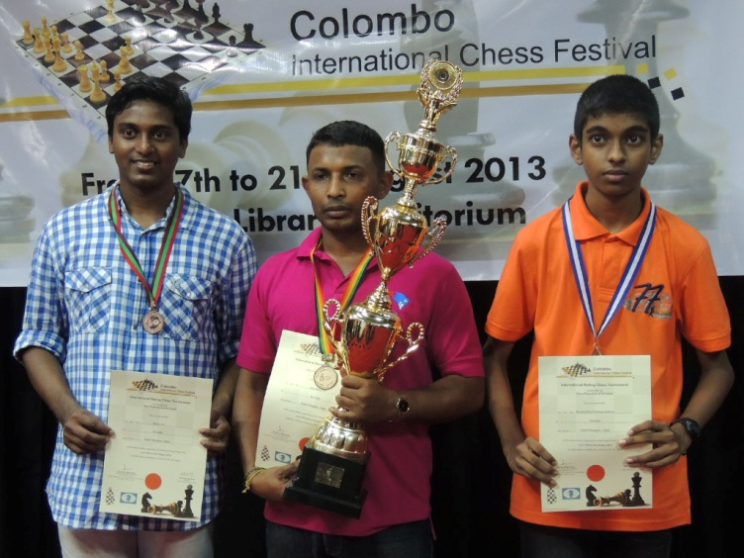
Three players tied for the 1st place
Other Category Prizes are as follows;
Under 15 Yrs
- Minul Doluweera
- Mojitha Gunaratne
- Supun Kuruppu
- HC Jithmal Gamage
Under 15 Yrs Girls
- Sajini Balasuriya
- Dasuni Mendis
- Ishini Wickramasinghe
- Devni Sathma
- PARR Nonis
Under 12 Yrs
- Sasith Nipun Piyumantha
- Ashen Kurukulasuriya
- Bhanuka Wickramasinghe
Under 12 Yrs Girls
- Sasanka Tennakoonwela
- Roshell Askey
- Himasha Jayasekara
- Nirasha Gamage
- Vineli Bandara
- Nevinka Kanakaratne
- GPY Wijesuriya
- Maheshika Madurapperuma
- BTAY Senarath
- Gihansa Rathnayake
Under 10 Yrs
- Malan Pathirana
- Saranath Nanayakkara
- Gayasha Kiriella
- Aloka Fernando
Under 10 Yrs Girls
- Sachintha Kodikara
- Isuri Vithanage
- Devnethmi Dahampriya

Under 8 Yrs
- Banindu Dahanayake
- Akkshara Wanigaratne
- Sanjeewan Sooriyakumar
Under 8 Yrs Girls
- Miyuni Jayasinghe
- Thenumi Seneka
- Ashvini Pavalchandran
- Thenugi Jayasinghe
- Nisansa Jayasundara
- Nethmie Dilanya
- Sayuni Weerasiri
Best unrated
- Diyoni Weerasinghe
- Sachintha Manage
- Dulmi Weeraman
- Ruwith Randev
- Sulakna Karunaratne
- Randil Dissanayake
Rating Below 1600
- SR Deegoda
- Rahul Jeyanthan
- Prabhath Lokuge
- CC Weerasinghe
- Thithira Fernando
- OVDKR weerasena
- Malith Nilanga
- Hansana Keshan
Rating Between 1600 and 1799
- Chathulanka Gamage
- Nipuna Kulasinghe
- TK Uyanhewage
- KDT Madushan
- LDP Madusanka
- Iraja Abhimanyu
- BKB Yaparatne
Rating between 1800 and 1999
- C. Lamahewa
- Chamil Priyankara
- JMMP Fernando

