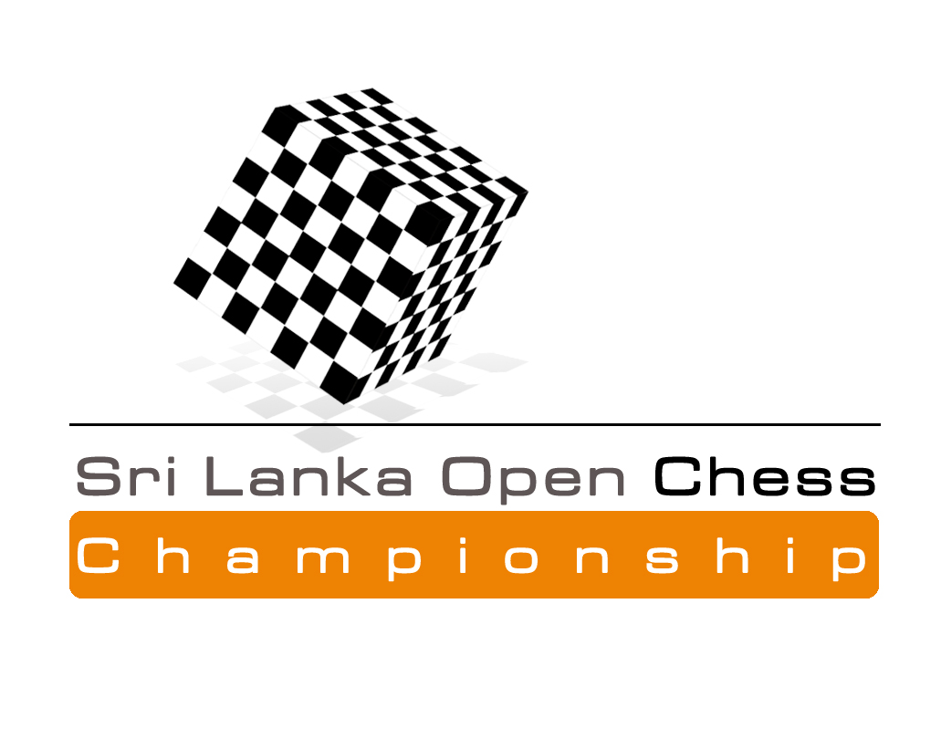
An International Rating Chess Tournament



From 7th to 11th August 2016

Mahamathya Vidyalaya, Colombo 6, Sri Lanka

Sri Lanka Open International Rating Chess Championship 2016

The Sri Lanka Open International Rating Chess Championship 2016 is an International Rating Open Chess event conducted by the Chess Federation of Sri Lanka with a total prize fund of nearly Rs. 400,000/=. This prestigious event organized from 1972 was made internationally rated from 2006.

Venue : Mahamathya Vidyalaya, Col. 06, Sri Lanka

Schedule: 06th August 2016 - Arrival
7th to 11th August - Round 1 to 10 (Report at 8.00 a.m on 20th August)
11th August at 7.00 p.m. - PDF
12th June – Departure
Eligibility : Open for all

Prizes :
Champion - Trophy, Gold Medal & Rs. 60,000/=
1st Runner up - Silver Medal & Rs. 40,000/=
2nd Runner up - Bronze Medal & Rs. 25,000/=
4th & 5th - Rs. 10,000/= each 6th to 15th - Rs. 5,000/= each

Best Girls
Champion - Trophy, Gold Medal & Rs. 20,000/=
1st Runner up - Silver Medal, Rs. 10,000/=
2nd Runner up - Bronze Medal Rs. 5,000/=

Best Unrated Player
Champion - Gold Medal & Rs. 5,000/=
1st Runner up - Silver Medal & Rs. 3,000/=
2nd Runner up - Bronze Medal & Rs. 2,000/=

Best Under 15 Boys & Girls separately
Champion - Gold Medal & Rs. 5,000/=
1st Runner up - Silver Medal & Rs. 3,000/=
2nd Runner up - Bronze Medal & Rs. 2,000/=

Best Under 12 Boys & Girls separately
Champion - Gold Medal & Rs. 5,000/=
1st Runner up - Silver Medal & Rs. 3,000/=
2nd Runner up - Bronze Medal & Rs. 2,000/=

Best Under 10 Boys & Girls separately
Champion - Gold Medal & Rs. 5,000/=
1st Runner up - Silver Medal & Rs. 3,000/=
2nd Runner up - Bronze Medal & Rs. 2,000/=

Best Under 8 Boys & Girls separately
Champion - Gold Medal & Rs. 5,000/=
1st Runner up - Silver Medal & Rs. 3,000/=
2nd Runner up - Bronze Medal & Rs. 2,000/=

Best Player - Rating category 1700 to 1900
Champion - Gold Medal & Rs. 5,000/=
1st Runner up - Silver Medal & Rs. 3,000/=
2nd Runner up - Bronze Medal & Rs. 2,000/=

Best Player - Rating category 1500 - 1700
Champion - Gold Medal & Rs. 5,000/=
1st Runner up - Silver Medal & Rs. 3,000/=
2nd Runner up - Bronze Medal & Rs. 2,000/=

Best Player - Rating category less than 1500
Champion - Gold Medal & Rs. 5,000/=
1st Runner up - Silver Medal & Rs. 3,000/=
2nd Runner up - Bronze Medal & Rs. 2,000/=

All participants will be provided with participation certificates.

Accommodation : All foreign players with more than 2000 ELO rating will be provided accommodation. All other Foreign Rated Players have to pay US $ 20 per person in a double/ Triple room per day as Accommodation costs.

Travel Grant
GMs, IMs, WGMs, WIMs, with the ELO of 2300 (2200 for WIMs) will be given a travel grant of Rs. 12,000/=

Entry Fee
All title players (FM/WFM and above) and rating above 2200are free.
All Rated players having a rating between 2200 and 2000 : Rs. 1,000/=
All Rated players having a rating between 2000 and 1500 : Rs. 2,000/=
All Rated players having a rating less than 1500 : Rs. 2,500/=
Unrated players : Rs. 3,500/=
All amounts are in Sri Lankan Rupees.

Late fee of Rs. 500/= will be charged for the entries received after 3rd of August 2016 which is the registration deadline. This applies for rated players, whom can do registration even via Email, as well. If any rated player registers and does not play without earlier notice will be removed from all future CFSL events in this year.

All Inquiries & entries to

Luxman Wijesuriya
Chairman, Organizing Committee,
Hony. Secretary CFSL,
151/12,Siridhamma Mawatha,
Colombo 10, Sri Lanka.
Telephone : 0094715397829
Fax : 0094112650622
Email cfslnew@gmail.com

Naditha Amarakoon 0775792372
Vice President
Buddhi Panagoda 0719295352
Hony. Secretary

Also can register with the relevant entry fee:
Mr. RS Kalugampitiya, 0773626376
Mr.Werochana Perera, 0717400249
Gihan Dinesh, 0777620964
JKC Ketalawala 0715130654
Shamin De Moraeas 0712297180
Lalantha Mudalige
Prsanna Kurukulasuriya 0777778270
Malith Akalanka 0718740372
Naditha Amarakoon 0775792372
Dayal Siriwardena 0718560211

Be a part of this historical Chess event!

Luxman Wijesuriya
Tournament Secretary - CFSL
General Secretary – Commonwealth Chess Association
Sri Lanka Open Chess Championship '16
From 7th to 11th August 2016

Entry Form

Name …………...................................................................................

Address & Telephone…..……………..............................................

……………………………………………….......................................

E-mail:……………………………………………………………….

Rating……….......................................................................................

FIDE ID:………………………………CFSL ID…………………

Club/ School…..…………….............................................................

Birthday…………………………… Sex……….......................

We abide by the Rules and Regulations of the event. All the details given above are true to the best of our knowledge.

Signature Date

All players are requested to register with the Chess Federation. Facilities to register with CFSL will be arranged at the tournament venue. Everyone is requested to forward an email address when registering to enable the communication with CFSL easier.

