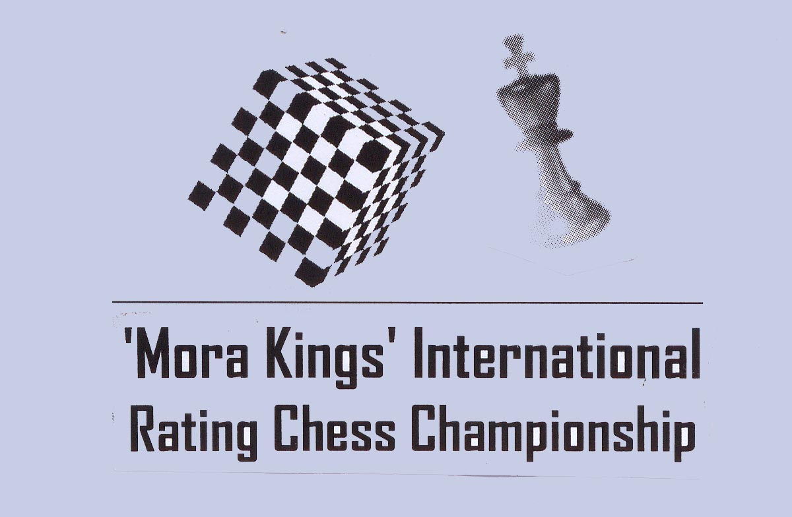

Organized by
The University of Moratuwa



From 4th to 8th August 2012
University of Moratuwa
Sri Lanka

5th 'Mora Kings'
International Rating Chess Championship 2012

The 5th 'Mora Kings' International Rating Chess Championships 2012 organized by the University of Moratuwa, on be half of CFSL and the FIDE will be held at the University of Moratuwa from 3rd(arrival) to 9th (Departure) of August 2012 with a total cash prizes of nearly Rs. 250,000/= worth.

Venue : University of Moratuwa, Sri Lanka.

Schedule: 3rd August - Arrival
4th to 7th August - Round 1 to 8
8th August - Round 9 and PDF
9th August - Departure
Eligibility : Open for all

Prizes :
Champion - Trophy, Gold Medal & Rs. 50,000/=
1st Runner up - Silver Medal & Rs. 25,000/=
2nd Runner up - Bronze Medal & Rs. 15,000/=
4th -5th - Rs. 10,000/= each
6th to 12th - Rs. 5,000/= each

Best Girls
Champion - Trophy, Gold Medal & Rs. 10,000/=
1st Runner up - Silver Medal, & Rs. 6,000/=
2nd Runner up - Bronze Medal & Rs. 4,000/=

Best Unrated Player
Champion - Gold Medal & Rs. 5,000/=
1st Runner up - Silver Medal & Rs. 3,000/=
2nd Runner up - Bronze Medal & Rs. 2,000/=

Best Under 15 Boys & Girls separately
Champion - Gold Medal & Rs. 5,000/=
1st Runner up - Silver Medal & Rs. 3,000/=
2nd Runner up - Bronze Medal & Rs. 2,000/=

Best Under 12 Boys & Girls separately
Champion - Gold Medal & Rs. 5,000/=
1st Runner up - Silver Medal & Rs. 3,000/=
2nd Runner up - Bronze Medal & Rs. 2,000/=

Best Under 10 Boys & Girls separately
Champion - Gold Medal & Rs. 5,000/=
1st Runner up - Silver Medal & Rs. 3,000/=
2nd Runner up - Bronze Medal & Rs. 2,000/=

Best Under 8 Boys & Girls separately
Champion - Gold Medal & Rs. 5,000/=
1st Runner up - Silver Medal & Rs. 3,000/=
2nd Runner up - Bronze Medal & Rs. 2,000/=

Best Player - Rating category 1800 to 2000
Champion - Gold Medal & Rs. 5,000/=
1st Runner up - Silver Medal & Rs. 3,000/=
2nd Runner up - Bronze Medal & Rs. 2,000/=

Best Player - Rating category less than 1800 and over 1600
Champion - Gold Medal & Rs. 5,000/=
1st Runner up - Silver Medal & Rs. 3,000/=
2nd Runner up - Bronze Medal & Rs. 2,000/=

Best Player - Rating category less than 1600
Champion - Gold Medal & Rs. 5,000/=
1st Runner up - Silver Medal & Rs. 3,000/=
2nd Runner up - Bronze Medal & Rs. 2,000/=

All amounts are in Sri Lankan Rupees.

All participants will be provided with certificates.

Accommodation : IMs and above titles with higher rating will be given everything free. All foreign players with an ELO ratings more
than 2000 will be provided free accommodation. All other foreign players have to pay US $ 50 for the accommodation only for 6 nights. All accommodations are set at houses rented by the organizers. (No A/C)
Travel Grant
GMs, IMs, WGMs, WIMs having over 2300 ELO will be given a travel grant of SL Rs. 12,000/=

Entries
Dead line for entries is 31st July 2012 to the undersigned. You may hand over the entries with relevant fee to the following regional officials
- Jagath Ketalawala (Kegalle) 0715130654
- Verochana Perera (Kurunegala) 0717400249
- Samin De Moraes (Gampaha) 0712297180
- RS Kalugampitya (Kandy) 0715601237
- LV Mudalige (Kandy) 0752082373
- Gihan Dinesh (Galle) 0714498167
- Rajiv Thilakaratne (Anuradhapura, Polonnaruwa) 0776221847
- Sumal Vithana (Kaluthara) 0714274432
- Buddhi Panagoda (Gampaha) 0719295352

Entry Fee
All title players and rating above 2200 are free.
Rated player above and 2000 ; Rs. 1000/=
Rated players above and 1600 : Rs. 1,500/=
Rated player below 1600 ; Rs. 2,500/=
Unrated players : Rs. 3,500/=
Late fee of Rs. 500/= will be charged for the entries received after 31st July 2012. This applies even for rated players, whom only are allowed to do registration even via Email

All Inquiries & entries to :
Mr. Luxman Wijesuriya
Secretary, Organizing Committee, Division of Physical Education,
University of Moratuwa, Moratuwa, Sri Lanka.
Telephone : 0715397829 Fax : 0112650622
Email - godigamu@yahoo.com

Be a part of this historical Chess event!

Luxman Wijesuriya KRDC Rathnamudali
Secretary, Organizing Committee Director of Physical Education

5th 'Mora Kings'
International Rating Chess Championship 2012
From 3rd (Arrival) to 9^{h} (Departure) August 2012
Entry Form

Name …………...................................................................................

Address & Telephone…..……………..............................................

……………………………………………….......................................

E-mail:……………………………………………………………….

Rating……….......................................................................................

FIDE ID:……………………………… CFSL ID…………………….

Club/ School…..…………….............................................................

Birthday……………………………………………….......................

We abide by the Rules and Regulations of the event. All the details given above are true to the best of our knowledge.

Signature Date

Note:- All players are requested to register with the Chess Federation. Facilities to register with CFSL will be arranged at the tournament venue. Everyone is requested to forward an email address when registering to enable the communication with CFSL easier.

