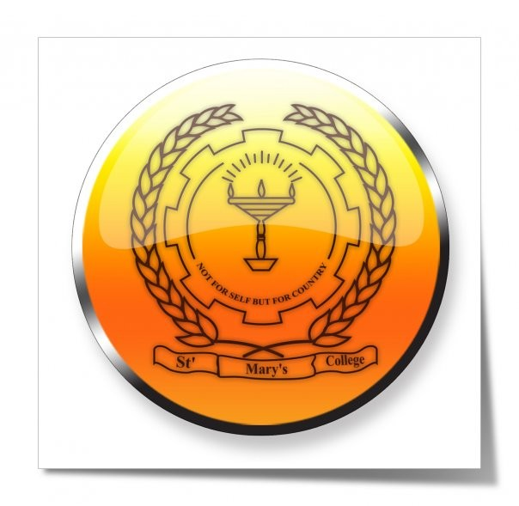
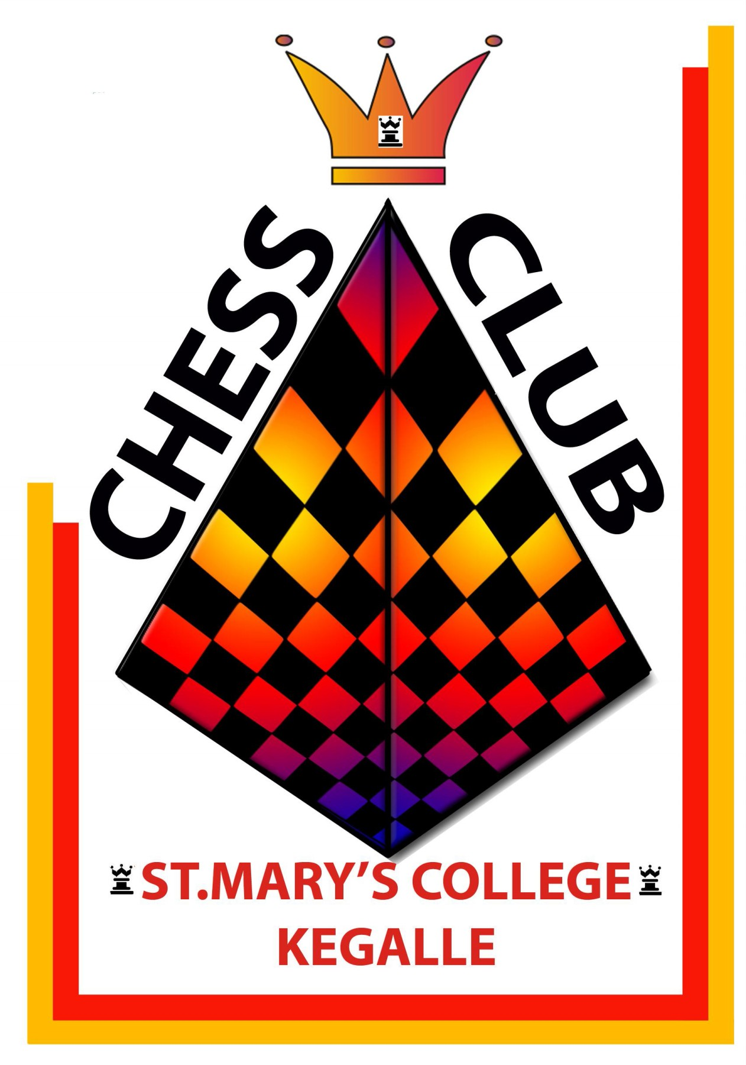
St. Mary's College Chess Club

All Island Inter School Chess Championship - 2011

St Mary's College Kegalle is organizing the all island inter school Chess championship "Marian's Challenge - 2011" on 17th and 18th September 2011 at college main hall, there will be a team event. Open for all under 10, 12, 14, 16 school teams.

Schedule

17th September 2011 7.00 a.m. - 7.30 a.m. Opening Ceremony
17th September 2011 7.30 a.m. - 8.00 a.m. Captains Meeting
17th September 2011 8.00 a.m. - 11.00 a.m. 1st Round
17th September 2011 12.00 noon - 3.00 p.m. 2nd Round
17th September 2011 3.30 p.m. - 6.30 p.m. 3rd Round

18th September 2011 8.00 a.m. - 11.00 a.m. 4th Round
18th September 2011 12.00 noon. - 3.00 p.m. 5th Round
18th September 2011 4.30 p.m. Closing ceremony & Prize giving

Eligibility

Open for all school teams who under 10 , 12 , 14 , 16. All players should be their age categories of age on 31st December 2011. There are 7 players per team with 1 reserve.

Accommodation

Will be provide - contract Mr. Indika Jayawardana. 071 - 8395830 Before 16th September 2011.

Entry Fee

An entry fee of Rs. 2000/= will be charged per team. Please confirm your participation as soon as possible by post or to following e-mail ketalawala82@gmail.com.

Prizes

Champions Team - Trophy + Gold Medal + Certificate
1st Runner up - Trophy + Silver Medal + Certificate
2nd Runner up - Trophy + Bronze Medal + Certificate

Best girl's Team - Trophy + Gold Medal + Certificate
Board Prizes - Gold Medal + Certificate

Inquires

Indika Jayawardana - 071-8395830

Jayantha Ketalawala - 077-7119463

Please Note :-

 All team participate with school uniforms is highly appreciated.

 Each team should bring 3 chess sets and as many chess clock as possible.

